

SubstrateX® Longitudinal Labs

Discovery Note 01 — Evidence-Horizon Sensitivity in Longitudinal Runtime Evidence
A Pre-Unblinding Analysis of Claim Persistence, Withdrawal, Re-entry, and Coordinate Revision Across 275 Prospective Evidence Horizons

SubstrateX® Longitudinal Computational Dynamics Research Program ·
Internal Technical Study · Version 0.1 · 19 October 2026

Author: Arjay Asadi
Position: Founding Architect, SubstrateX®
Affiliation: SubstrateX® Longitudinal Labs
Research: Longitudinal Computational Dynamics® · Runtime Evidence · Evidence-Governed Computation™ · Chronodynamics
Status: FROZEN PRE-UNBLINDING INTERNAL DISCOVERY

Front Matter

Abstract
A prospective prefix replay of the Waypoint T1–T275 trajectory exposed a methodological phenomenon that is not visible from a completed retrospective reconstruction alone. Aperture was recomputed independently at every native source-turn horizon, with no future-event leakage and with the external PsiGuard intervention/wandering coordinates withheld. The replay showed that some claims were highly stable under growing evidence while others were repeatedly issued, withdrawn, relocated, and reissued. The staged weakening coordinate t_aw=T2 was invariant at every computable horizon after T2. By contrast, candidate-boundary status appeared at T2, withdrew and re-entered repeatedly, and became status-persistent only at T168; even after status persistence, its reconstructed coordinate continued to change. Most strikingly, formal t* was issued at 32 prefix horizons across 30 issuance episodes, withdrawn 30 times, and absent in the completed T275 record. Selected-prefix repeats reproduced these states deterministically.
This study names the phenomenon Evidence-Horizon Sensitivity: the degree to which an evidence-authorized finding, marker, regime, coordinate, or claim changes as the admissible evidence horizon expands. Its complement is Horizon Invariance. The central methodological conclusion is that deterministic replay at a fixed horizon does not imply longitudinal claim stability under later admissible evidence. The note proposes a set of horizon-stability metrics, separates status invariance from coordinate invariance, introduces a provisional Horizon Non-Monotonicity Principle, and recommends preserving claim revision lineage as part of Runtime Evidence. The result is intentionally bounded to one trajectory and remains pre-unblinding with respect to PsiGuard.

Research Status and Scope
This document is an internal discovery record created before PsiGuard coordinate disclosure. It documents a methodological phenomenon observed in one frozen prospective replay and proposes terminology, metrics, and preservation structures for follow-up study. It is not a numbered foundational paper and does not claim general scientific validity.

Core Discovery
A longitudinal claim can be deterministic at a given evidence horizon yet fail to remain invariant as the admissible evidence horizon expands.

Contributions
1. Names Evidence-Horizon Sensitivity and Horizon Invariance as distinct methodological objects.
2. Separates prefix-valid issuance from persistence under later admissible evidence.
3. Separates claim-status persistence from claim-coordinate persistence.
4. Quantifies the T1–T275 blind replay: warning HSR 100.0%, candidate HSR 66.1%, formal t* HSR 12.0%.
5. Introduces provisional metrics for first issuance, persistent issuance, persistence lag, withdrawals, re-entry, coordinate revision, and terminal agreement.
6. Proposes claim revision lineage as a Runtime Evidence preservation requirement.
7. Introduces a provisional Horizon Non-Monotonicity Principle for multi-case testing.
8. Defines a replication protocol that can determine whether the phenomenon generalizes beyond this trajectory.

Discovery Context

From prospective replay to a new validation question
The Waypoint/PsiGuard experiment was designed to distinguish completed-trajectory reconstruction from prefix-bounded prospective issuance. The same verdict-free T1–T275 source was recomputed independently at every native source-turn horizon. No future event was admitted into an earlier prefix, and PsiGuard intervention or wandering coordinates remained withheld.
The completed run presents a compact terminal authority: weakening at T2, candidate boundary T25, formal t* not confirmed, tf not supplied, and a Transitional final regime. Prospective replay showed that the route to those terminal statements was not uniform. Some claims were stable from their first admissible horizon; others flickered, relocated, or disappeared as the evidence horizon expanded.

Discovery statement
A longitudinal claim can be deterministic at a given evidence horizon yet fail to remain invariant as the admissible evidence horizon expands.
Selected-prefix repeats reproduced the same claim states exactly. The observed variation is therefore associated with changes in admissible evidence horizon, not with stochastic rerun behavior in the tested prefixes.

Definitions and Formal Distinctions

Evidence horizon
Let H_k denote the admissible evidence horizon containing source evidence through native source turn k. The underlying historical prefix H_k remains fixed whenever that horizon is recomputed.

Evidence-Horizon Sensitivity
Evidence-Horizon Sensitivity (EHS) is the degree to which an evidence-authorized finding, marker, regime, coordinate, confidence state, or claim class changes as the admissible evidence horizon expands.
• Status sensitivity — whether the claim is issued, sustained, withdrawn, or reissued.
• Coordinate sensitivity — whether an active claim remains anchored to the same coordinate.
• Claim-class sensitivity — whether authority changes among candidate, confirmed, unavailable, or other governed classes.
• Confidence sensitivity — whether evidentiary confidence strengthens or weakens.
• Regime sensitivity — whether the governing regime classification changes.

Horizon Invariance
A claim component is horizon-invariant over a declared interval when later admissible evidence does not alter that component except through an explicitly permitted revision rule. Invariance must therefore name the component being tested: status, coordinate, claim class, confidence, or the full claim object.

Prefix validity versus horizon stability
Prefix validity asks whether a claim was admissible using only evidence available at H_k. Horizon stability asks whether that claim survives later admissible evidence. A claim may be validly issued at H_k and still be withdrawn at H_{k+1}; the two properties must not be conflated.

Experimental Basis
Property | Frozen value
Native source turns | 275
Prefix horizons | 275
Computable prefixes | 274
Terminal canonical events | 550
Terminal eligible measurements | 271
Method Contracts | 48 / 48 PASS
Future-event leakage | 0
PsiGuard annotations used | No
Certified run | APERTURE-CER-6753eadcdd506
Terminal regime | Transitional
Terminal t_aw | T2
Terminal candidate | T25
Terminal formal t* | null / not confirmed
Terminal tf | null / not supplied
The prefix ledger was frozen before PsiGuard coordinate disclosure. A separate browser-versus-harness identity reconciliation later established 550/550 canonical-event equivalence and classified the terminal hash discrepancy as identity bookkeeping rather than a source, measurement, or scientific-result difference. No prefix science was recomputed or altered for this study.

Empirical Findings

Weakening is horizon-invariant after T2
The staged warning first becomes available at T2 and remains active at every computable horizon through T275. Its reconstructed t_aw coordinate remains T2 throughout. First issuance T2; persistent issuance T2; persistence lag 0; HSR 100.0%; withdrawals 0; re-entries 0.

Candidate status becomes persistent only at T168
Candidate status first appears at T2 but occupies 181 of 274 horizons after first issuance (HSR 66.1%). It forms 14 issuance episodes, withdraws 13 times, re-enters 13 times, and becomes continuously present only at T168. Persistence lag from first issuance is 166 turns.
Candidate issuance intervals: T2–T5; T10; T12–T17; T20–T68; T71; T77; T93; T109; T118; T122–T126; T143; T157; T161; T168–T275.

Status persistence does not imply coordinate invariance
Across candidate-positive horizons, Aperture uses 30 distinct candidate coordinates and performs 61 coordinate revisions. The terminal retrospective coordinate T25 is present at only 70 of 181 candidate-positive horizons (38.7%).
From T168 through T275, candidate status is continuously present, yet the coordinate still spans 13 values with 37 revisions; only 38 of 108 horizons (35.2%) use T25. Status persistence and coordinate persistence are therefore empirically distinct in this run.

Formal t* is deterministic at selected horizons but never persistent
Formal t* is active at 32 horizons across 30 issuance episodes. It first appears at T10, has HSR 12.0%, withdraws 30 times, and re-enters 29 times after first issuance. No persistent issuance horizon exists. The completed T275 record has t*=null / not confirmed.
Formal issuance horizons: T10, T20, T21, T22, T25, T44, T56, T62, T71, T77, T87, T93, T109, T118, T126, T143, T157, T161, T168, T170, T187, T196, T205, T212, T215, T220, T226, T229, T235, T237, T245, T258.

Regime classification is horizon-sensitive
Across 274 computable horizons, Transitional occurs at 207 horizons (75.5%), Collapse at 34 (12.4%), and Stable at 33 (12.0%). The sequence contains 109 regime runs and 108 transitions.
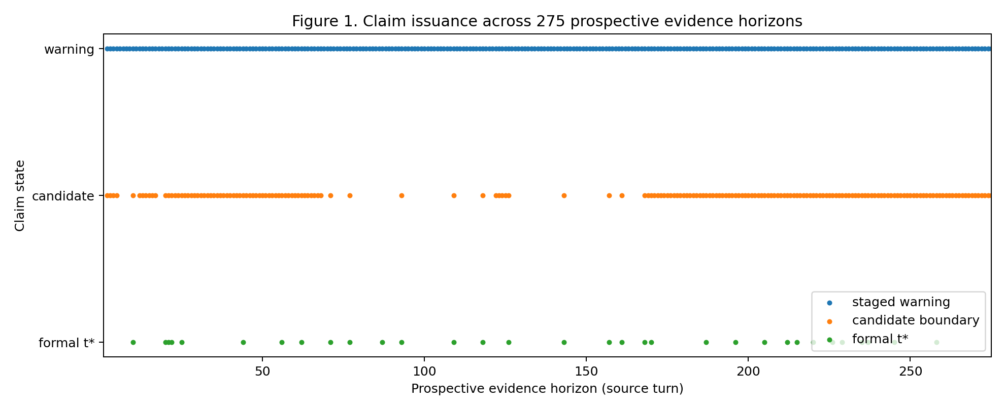
Figure 1. Claim issuance across 275 prospective evidence horizons. Warning remains present after T2; candidate status is intermittent until T168; formal t* is sparse and repeatedly withdrawn.
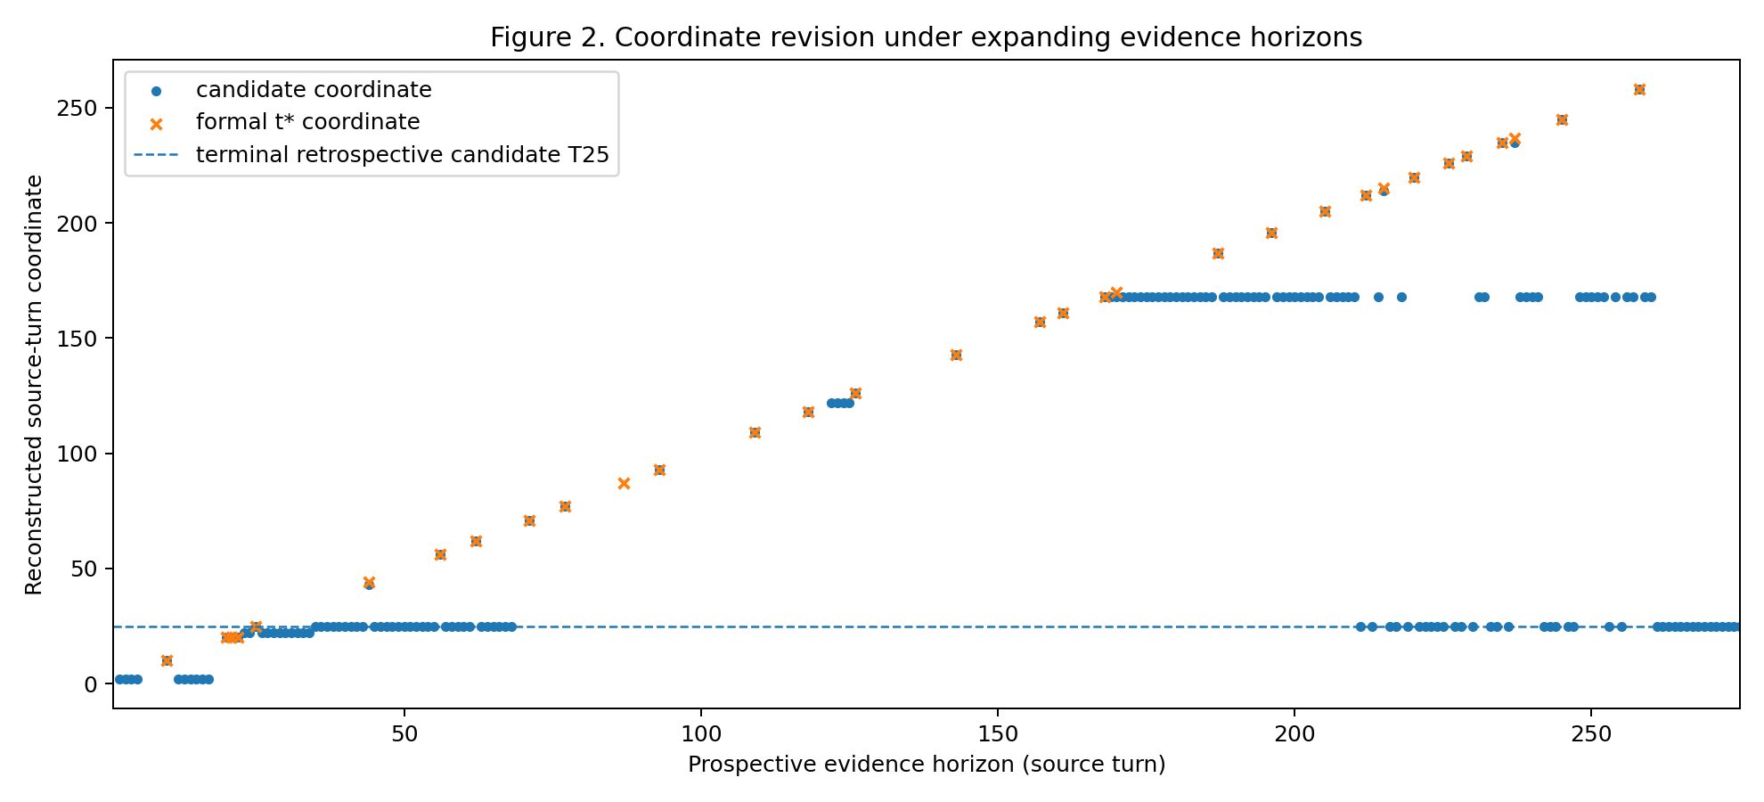
Figure 2. Candidate and formal-boundary coordinates under expanding evidence. Candidate status can remain active while its reconstructed coordinate continues to revise.
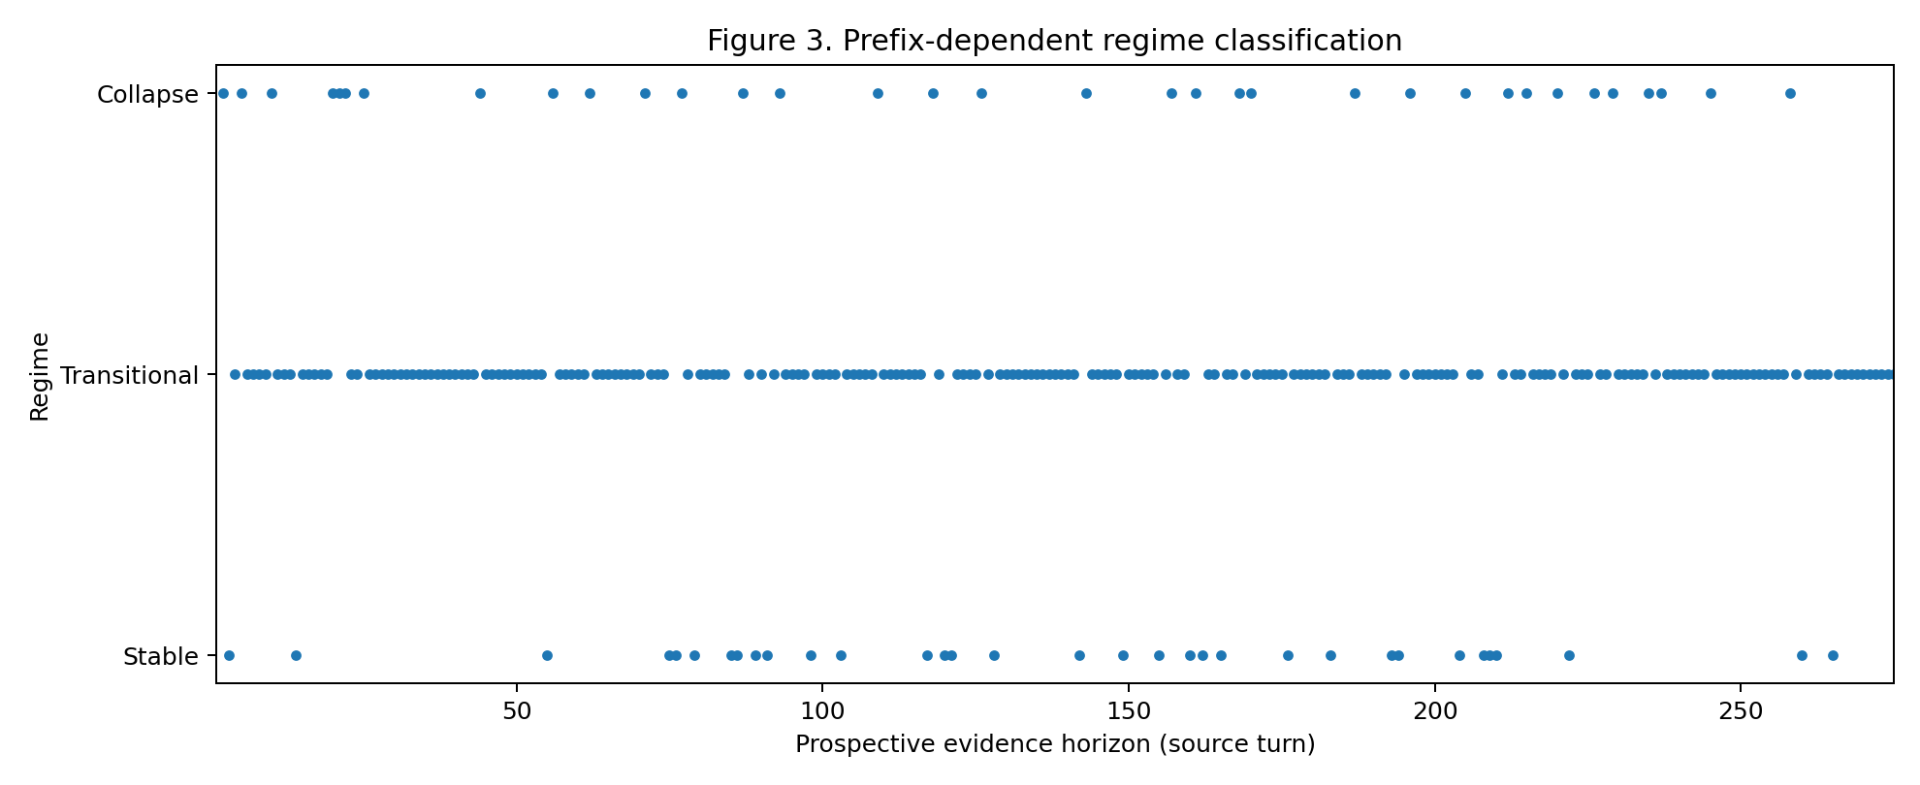
Figure 3. Prefix-dependent regime classification across computable horizons. Terminal Transitional state does not imply prospective regime invariance.

Proposed Horizon-Stability Metrics

Metric set
Metric | Definition
First Issuance Horizon (H_first) | Earliest admissible horizon at which the claim is issued.
Persistent Issuance Horizon (H_persist) | Earliest horizon after which the claim remains issued through the terminal horizon.
Persistence Lag (L_p) | H_persist − H_first; undefined when no persistent horizon exists.
Horizon Stability Ratio (HSR) | Active horizons divided by horizons from H_first through the terminal horizon.
Withdrawal Count (W) | Number of issued/sustained → inactive transitions.
Re-entry Count (R) | Number of post-withdrawal inactive → issued transitions.
Coordinate Revision Count (CRC) | Changes in claim coordinate across successive active horizons.
Terminal Coordinate Agreement Ratio | Among active horizons, fraction whose coordinate equals the terminal retrospective coordinate.

Observed values in the Waypoint run
Claim | H_first | H_persist | Lag | HSR | W | R
Warning / weakening | T2 | T2 | 0 | 100.0% | 0 | 0
Candidate boundary | T2 | T168 | 166 | 66.1% | 13 | 13
Formal t* | T10 | — | — | 12.0% | 30 | 29
These metrics are proposed descriptive measures for follow-up analysis. They are not yet standardized or externally calibrated.

Provisional Horizon Non-Monotonicity Principle
Additional evidence does not necessarily strengthen an existing longitudinal claim. New admissible evidence may preserve, strengthen, weaken, relocate, withdraw, or reissue a previously admissible finding.
The principle remains provisional because the present study contains one trajectory. Its immediate value is methodological: it prohibits an untested assumption that more evidence must monotonically increase claim authority.

Implications for Evidence-Governed Computation

Revision is part of the evidence object
A final claim state can erase meaningful evidence history. Runtime Evidence should preserve issuance, withdrawal, re-entry, coordinate revision, confidence, method version, evidence basis, and terminal status.

Prospective evaluation needs more than onset accuracy
Evaluation of only the first positive horizon can overstate detector utility when a claim later withdraws repeatedly. Persistence and revision behavior should be reported alongside onset.

Evidence refusal remains a result
The terminal T275 refusal to confirm Basin Exit must coexist with the preserved record of earlier formal emissions. Neither the final refusal nor the earlier emissions should overwrite the other.

Authority should distinguish state from coordinate stability
A marker may be continuously present while its coordinate continues to move. Claim status and claim anchor therefore require separate authority fields and validation checks.

Implications for Chronodynamics
Chronodynamics distinguishes historical reconstruction from prospective replay. Evidence-Horizon Sensitivity adds a second axis: prospective admissibility at one horizon versus persistence under later horizons. A complete temporal analysis should therefore ask what the completed trajectory supports, what could be issued at H_k, and how stable that issued claim remains as H expands.

Validation Consequences
The discovery motivates Horizon Stability / Revision Consistency as a cross-cutting validation dimension. It does not replace the existing validation ladder. It asks whether prospective claim behavior remains coherent under evidence growth and whether revision semantics match the registered Method Contract.
• withdrawal frequency and duration
• time to persistent issuance
• coordinate revision and terminal agreement
• confidence monotonicity or reversal
• sensitivity near thresholds and hysteresis boundaries
• negative-control claim flicker
• cross-source/model transport
• independent replay of the same horizon sequence

Follow-Up Replication Program
The next study should repeat the prefix experiment across stable controls, transition cases, recovery cases, independently anchored failure-confirmed cases, long open-watch cases, and multiple model/source families. The companion replication protocol freezes the required fields, controls, metrics, falsification conditions, and promotion criterion.

Relationship to Paper VIII
Paper VIII should report Evidence-Horizon Sensitivity as a major pre-disclosure empirical finding of the Waypoint/PsiGuard experiment, while keeping this phenomenon analytically independent of the later cross-system outcome. The discovery occurred before PsiGuard coordinates were available. Agreement or disagreement with PsiGuard cannot retroactively create, remove, or redefine the horizon-sensitivity observation.

Limitations
• The study analyzes one long-horizon trajectory and one Aperture implementation.
• It does not yet distinguish desirable evidence revision from over-sensitive marker logic across a representative case set.
• It does not estimate population prevalence or calibrated predictive performance.
• The formal t* flicker may expose a method-design weakness that should be investigated only after the blind comparative experiment is completed.
• PsiGuard coordinates remain undisclosed and are not part of this analysis.
• The provisional Horizon Non-Monotonicity Principle requires multi-case replication before elevation to a general scientific proposition.

Conclusion
The Waypoint T1–T275 prospective replay revealed that deterministic issuance and horizon invariance are separate properties. Weakening was completely invariant after T2. Candidate status was non-monotonic before becoming persistent at T168, while its coordinate continued to revise even after status persistence. Formal t* was deterministically issued at 32 horizons, repeatedly withdrawn, and absent from the completed record. These observations justify Evidence-Horizon Sensitivity as a distinct methodological object for further study and support preservation of claim revision lineage as part of prospective Runtime Evidence.

References and Internal Evidence Basis
1. Asadi, A. (2026). Longitudinal Computational Dynamics: Foundations of Computational Organization Across Extended Runtime. Longitudinal Computational Dynamics Series, Paper I. SubstrateX®.
2. Asadi, A. (2026). Validating Longitudinal Computational Dynamics: Deterministic Runtime Evidence and Discrimination. Longitudinal Computational Dynamics Series, Paper II. SubstrateX®.
3. Asadi, A. (2026). Foundations of Evidence-Governed Computation. Longitudinal Computational Dynamics Series, Paper VI. SubstrateX®.
4. Asadi, A. (2026). Foundations of Chronodynamics. Longitudinal Computational Dynamics Series, Paper VII. SubstrateX®.
5. APERTURE_T1-T275_PROSPECTIVE_PREFIX_LEDGER_FINAL.csv — frozen prospective prefix ledger.
6. APERTURE_T1-T275_PHASE3_PROSPECTIVE_PREFIX_REPORT.md — pre-unblinding Phase 3 report.
7. APERTURE_T1-T275_BLIND_RESULT_LOCK_v2.json — reconciled pre-disclosure lock.
8. APERTURE_T1-T275_IDENTITY_RECONCILIATION.json — terminal identity reconciliation.

Appendix A — Formal t* Issuance Horizons
T10, T20, T21, T22, T25, T44, T56, T62, T71, T77, T87, T93, T109, T118, T126, T143, T157, T161, T168, T170, T187, T196, T205, T212, T215, T220, T226, T229, T235, T237, T245, T258

Appendix B — Candidate Issuance Intervals
T2–T5; T10; T12–T17; T20–T68; T71; T77; T93; T109; T118; T122–T126; T143; T157; T161; T168–T275

Appendix C — Companion Materials
The package includes the horizon-sensitivity metrics JSON; enriched claim revision ledger CSV; transition-only revision ledger CSV; claim revision lineage JSON schema; replication protocol; frozen discovery record; derived figures; frozen source-evidence basis files; and SHA-256 manifest.

